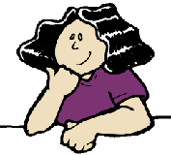
Name:___________________________________________

Simple Genetics Practice Problems
- For each genotype, indicate whether it is heterozygous (HE) or homozygous (HO)
AA ____  Bb ____  Cc ____  Dd ____ | Ee ____  ff ____  GG ____  HH ____ | Ii ____  Jj ____  kk ____  Ll ____ | Mm ____  nn ____  OO ____  Pp ____
- For each of the genotypes below, determine the phenotype.
Purple flowers are dominant to white.  PP ___________________________  Pp ___________________________  pp ___________________________ | Brown eyes are dominant to blue eyes.  BB ___________________________  Bb ___________________________  bb ___________________________
Round seeds are dominant to wrinkled.  RR ___________________________  Rr ___________________________  rr ___________________________ | Bobtails are recessive (long tails dominant).  TT ___________________________  Tt ___________________________  tt ___________________________

- For each phenotype, list the genotypes. (Remember to use the letter of the dominant trait)
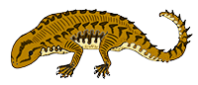
Straight hair is dominant to curly.  ____________ straight  ____________ straight  ____________ curly | Tail spikes are dominant to plain tails.  ____________ pointed  ____________ pointed  ____________ round

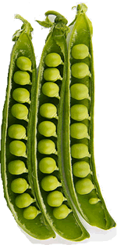
- Set up the square for each of the crosses listed below. The trait being studied is round seeds (dominant) and wrinkled seeds (recessive)

Rr x rr
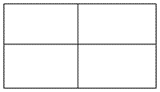
What percentage of the offspring will be round? _______

Rr x R r
What percentage of the offspring will be round? _______

RR x Rr
What percentage of the offspring will be round? ___________

Practice with Crosses. Show all work!
- A TT (tall) plant is crossed with a tt (short plant).
What percentage of the offspring will be tall? ___________
- A Tt plant is crossed with a Tt plant.
What percentage of the offspring will be short? ______
- A heterozygous round seeded plant (Rr) is crossed with a homozygous round seeded plant (RR).
What percentage of the offspring will be homozygous (RR)? ____________

- A homozygous round seeded plant is crossed with a homozygous wrinkled seeded plant.
What are the genotypes of the parents? __________ x __________
What percentage of the offspring will also be homozygous? _______
What is the genotype of all of the offspring? ______
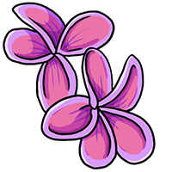
- In pea plants purple flowers are dominant to white flowers.

If two white flowered plants are cross, what percentage of their offspring will be white flowered? ______

- A white flowered plant is crossed with a plant that is heterozygous for the trait.
What percentage of the offspring will have purple flowers? _____________

- Two plants, both heterozygous for the gene that controls flower colour are crossed.
What percentage of their offspring will have purple flowers? ______________
What percentage will have white flowers? ___________

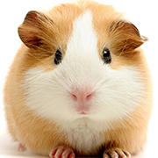
- In guinea pigs, the allele for short hair is dominant.
What genotype would a heterozygous short haired guinea pig have? _______
What genotype would a purebred short haired guinea pig have? _______
What genotype would a long haired guinea pig have? ________
Show the cross for two heterozygous guinea pigs.

What percentage of the offspring will have short hair? ________
What percentage of the offspring will have long hair? _______

